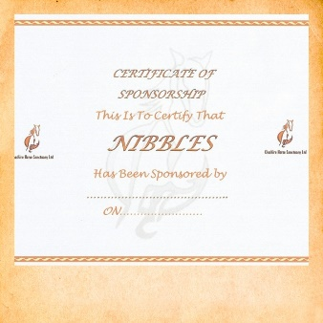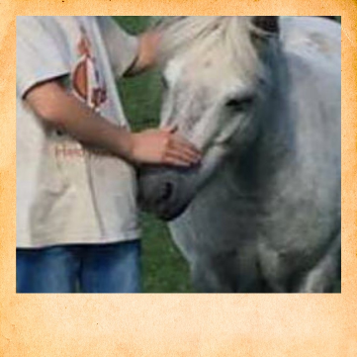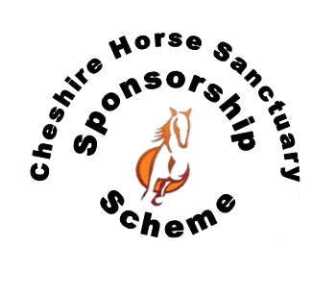

Purchasing the Pony Care

Package means you will support all the Ponies and

Horses in our care.

You will receive a fabulous Sponsorship Pack which includes

* A certificate with your sponsorship
* Lapel pin
* Picture of your pony
* One free visit to spend time with your new friend
* Sponsorships last for 12months

PONY CARE PACKAGE

£12.50

Unable to keep a horse or pony of your own? Why not make a new friend with one of our friendly herd members?

It is not always possible to re-home a member of the sanctuary, so to allow us to care for our horses, we need your help!

You can help us take care of our residents!

Your Sponsorship will go directly to supporting our horses and ponies in our care.

You’ll help provide

* **Equipment** – to manage their environment
* **Horse clothing** – to help keep them warm
* **Nutrition** – to help feed and give them grazing

Visit our website for more details of how your Sponsorship will provide essential care.

**www.cheshirehorsesanctuary.co.uk/sponsorship**

(one off payment)